

GAME DEVELOPMENT PROJECT

**Software Development – Game: Noughts and Crosses**



**July 3, 2018**

Name : Jason Fernandes  
Company : Bloomberg LP

# 

Introduction  
  
- Purpose of this document   
For this project, I will be creating a game of noughts and crosses on python. My manager has assigned me this project because it will help me illustrate some of the skills I have learned this year from code classes, shadowing colleagues in the programming team, as well as my self-learning of Python from the “Code Academy website”. As I have been working as a Data Analyst in the Analytics department in which my job has been primarily focused on the Bloomberg software. I have gone through and successfully completed different courses at Bloomberg, in order to provide solutions to clients questions and trainings in order to improve their usage of Bloomberg. As Noughts and Crosses is a game that requires logical thinking, the same can be said for my role in the Analytics department to understand client concerns and be able to give the client the correct solution. The reasoning behind her giving me the project is that when it ge

This is the document in which represents the game “Noughts and Crosses” which I have been able to create on python.

- How the game works   
When the program is first loaded, a game board is drawn up, a 9x9 square to be precise. It will then ask the user a question as to either selecting X or 0. Once the user inputs either the X or 0, player 2’s symbol will be determined automatically. For example, if player 1 selects X, then player 2 will be automatically allocated the 0 to play with and vice versa.

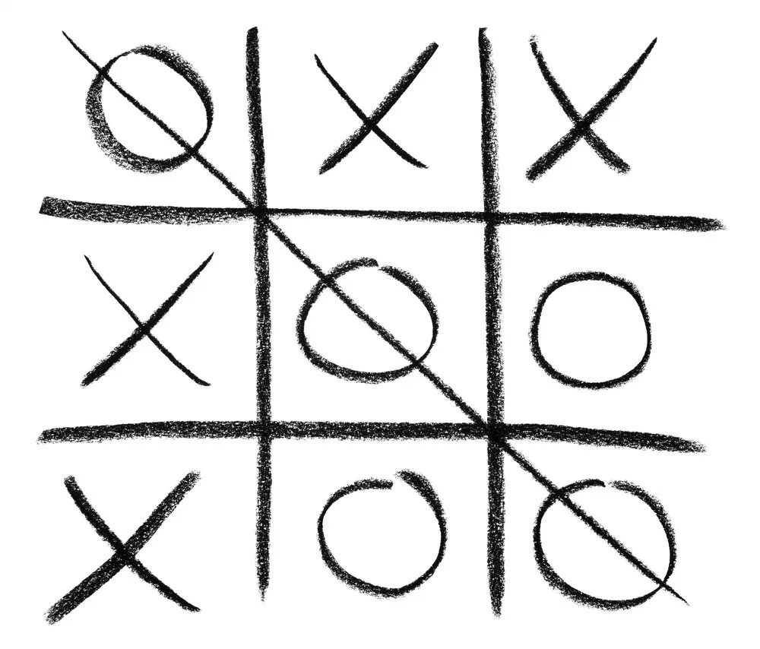Once the symbol in which they are playing with are selected [X or 0], player 1 will be asked to input a number from 0-8 because this number will determine which square they want to place their chosen symbol in. Then the result will be outputted in the allocated place on the 9x9 grid. The program will then continue until a winner is able to achieve three of their symbols in a row and the message ‘’Player [1 or 2] is the winner!’’ will be outputted from the program.

1. Introduction

1.1. Purpose of this Document

1.2. Management Overview

2. Project Overview

2.1. Solution Overview

2.2. Functional Requirements

2.3. Non Functional Requirements

2.4. Issues

2.5. Risks

2.6. Dependencies

2.7. Assumptions

2.8. Strategy and Solution Roadmap

2.9. Project Timescale

2.10. Deployment

2.11. Version Control/Source Management

3. Data Model

3.1. Data Flow Diagram

3.2. Entity Relationship Diagram

3.3. Object Layout

4. Reflection

4.1 Lesson learnt

4.2Improvement